**ANALYSIS:**

Background To Project – Section 1:

The Tube:

The London Underground (otherwise known as “The Tube”) is a transportation service used by approximately 2 million people per day. The system has been used since 1863. It started with only 1 line (the Metropolitan Line). 159 years later and the service now has 11 underground lines, 272 stations, and covers 420 km of the Capital. To people who don’t live in London or are not familiar with London, travelling via the tube can seem daunting; you could be accidentally getting on a train to the wrong place, or you might not know how to navigate around London by using a tube map because it is so overwhelming.

(Information from <https://en.wikipedia.org/wiki/London_Underground> )

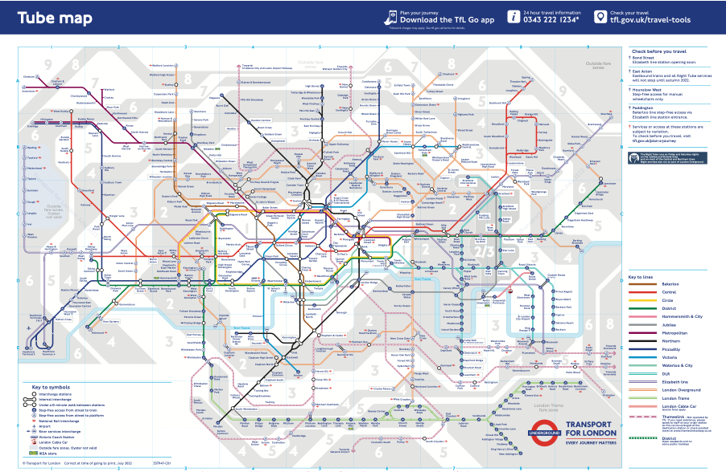The Map:

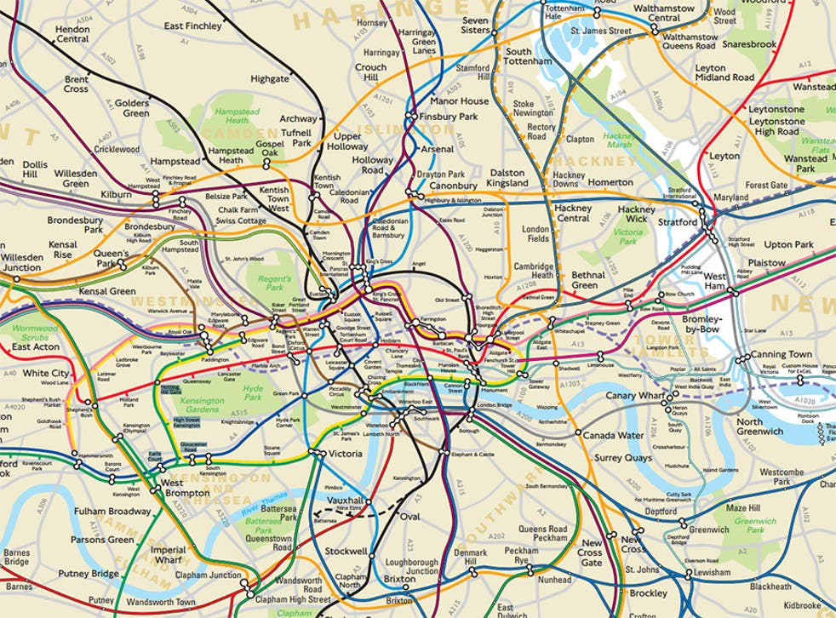The Tube Map is a “schematic transport map.” It contains information on the lines, the stations, the different zones, train stations, facilities, airports, and accessibility between street and train. The map uses representational abstraction – it removes unnecessary details in order to arrive at a representation. The map is not geographically accurate as London is not as linear as the map shows. The amount of abstraction used to create the tube map is astounding - so much so that it may confuse tourists if they look at a normal map.

The Problem:

Based on the previous few paragraphs, it has been established that the tube may be confusing and disorienting for some.

**This project aims to calculate the shortest path between two tube stations. The user will enter their start location and their desired destination, and a route will be outputted.**

The program will output the route that will take the least amount of time, the line that the user should take, and the amount of time taken to reach there (approximately). The project aims to help those new to London or those who are visiting London. It may even be helpful for people who live in London or visit London regularly as it can output approximate journey times.

The project will only focus on zone 1 of London. This is because including other zones won’t be very important since there are not as many ways to get to a single node, i.e., most of the time, the route between 2 nodes is the only route between them so it is not too difficult to navigate in other zones.

Current System – Section 2:

Maps by Apple: <https://apps.apple.com/us/app/apple-maps/id915056765>

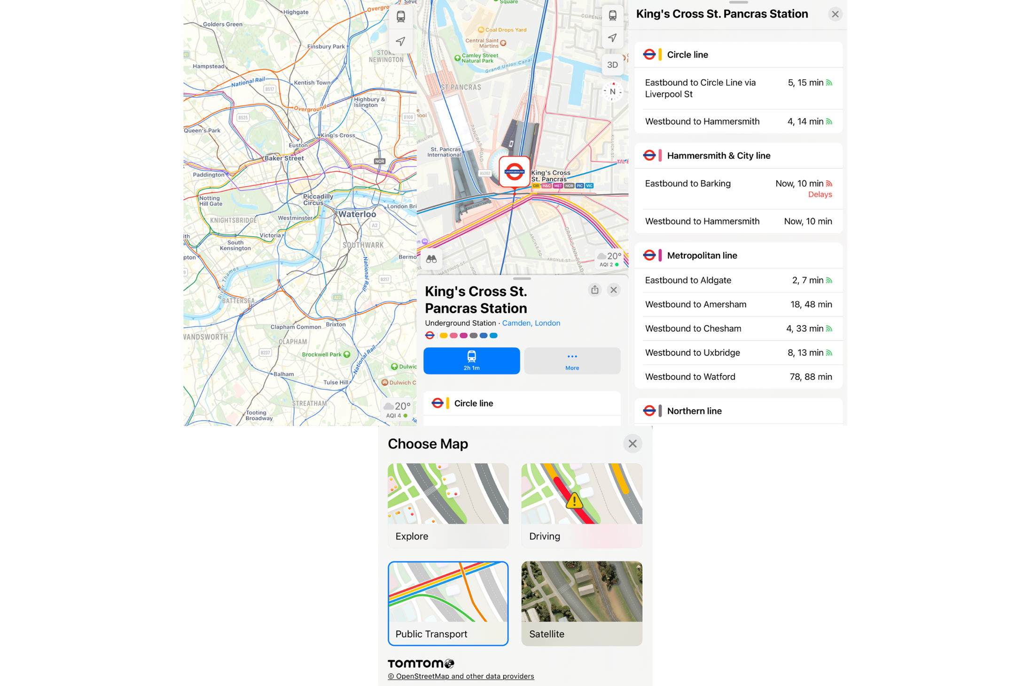Maps by Apple has multiple modes in which you can look at the Map. You can look in Explore Mode (which is the default mode you are put into), Driving Mode, Public transport Mode, and Satellite Mode. Personally, I was unaware of the different modes in the app, and when I asked a prospective end-user, they were also unaware of this feature.

In my opinion, this current system is difficult for users to find and most people using Apple Maps are unaware of the Tube features.

TfL Go: <https://tfl.gov.uk/maps_/tfl-go>

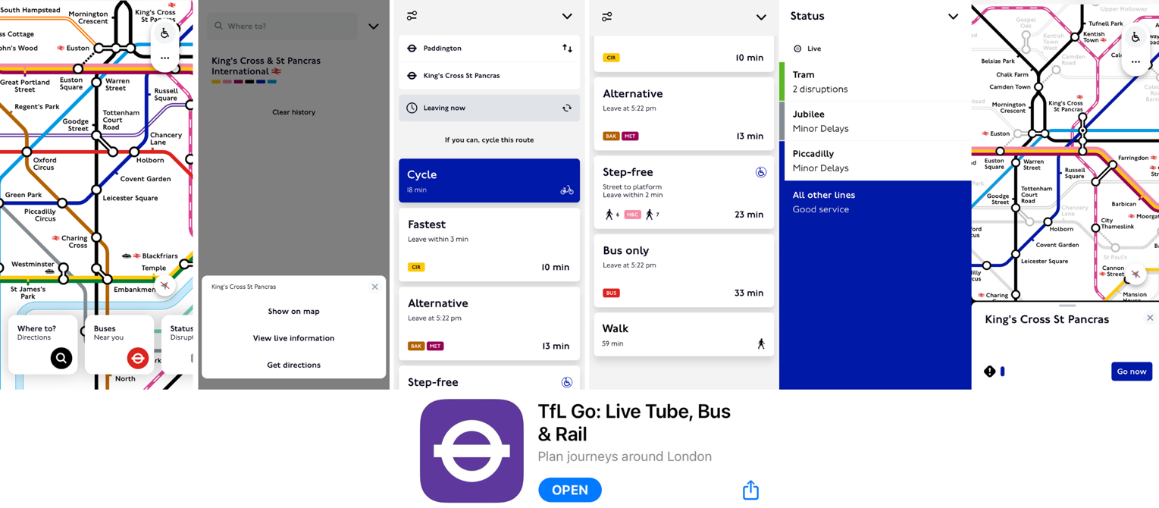Currently, Transport for London (TfL) have a mobile application called “TfL Go.” As soon as you open the app, a detailed map of all underground and overground trains appears. You can search up a location you would like to go to, and you can see live information on different lines, or get directions from a start location. It then gives you the best route to take, either by the tube or by alternative routes such as buses, walking etc. You can also check the status of disruptions on different lines in real-time. Additionally, if you tap on a tube station, you can see the different facilities there and the lines that run there get focussed.

This system is good; however, it may still be difficult for tourists to navigate as it may be a lot more complex than they would like. When using it, I found that it took long for me to get to the page where you can input start and end stations. Due to this, my project will have a less complex/complicated user interface which is based on simplicity for the user. Additionally, sometimes it outputs a route which involves getting the bus, or cycling. In my opinion, I dislike this feature, as I would prefer to navigate London via the Tube since it is quick and cheap. Therefore, my project will improve on this by only outputting routes via the Tube.

Citymapper: <https://citymapper.com/?lang=en>

“Citymapper” is a mobile application used to give users bus, train, and tube timings. It is number 6 in the app store navigation charts (at the time I researched current systems). It has more features compared to the “TfL Go” app, as it can also be used for navigating around Birmingham, Manchester, Liverpool, Edinburgh, Dublin, and many more cities in the UK, Europe, and across the globe. I found that with more information there is added complexity in this app. The information that it gives the user can be overwhelming and sometimes even unnecessary. For example, the image on the left is the first thing you see when you open the app, and the two images on the right are images of the journey planner/route planner feature:

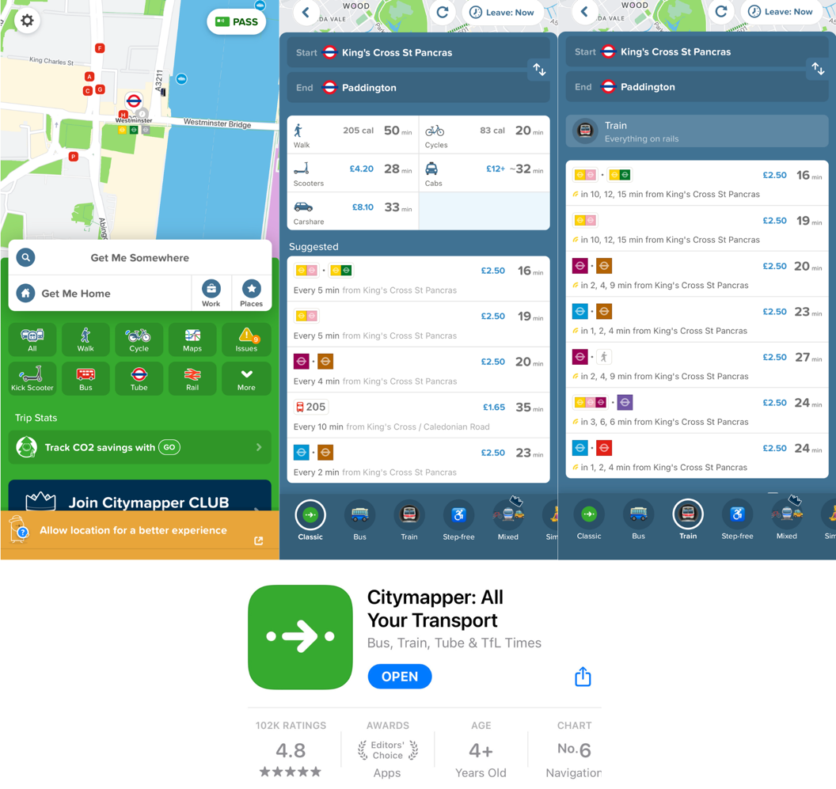

In my opinion, if I was new to London, I would be even more overwhelmed by this app than the tube map itself. However, I will find out other people’s views on the user interfaces of all of these apps in my interview.

Identification Of End Users – Section 3:

The end users will be people who struggle to navigate London using the tube. This may include:

* People who are new to London
* People who are tourists in London/are visiting London
* People who live in London

The program will be of use to people who are above 15 years old. I think the main demographic will be people who are new to London and tourists.

Essentially, people who are in London may need to use the app. Due to the fact that there are a wide range of people who could be using the program, it should be as user-friendly as possible (i.e., focussing on simplicity over aesthetics). Therefore, the user interface should not be overwhelming with lots of colours etc, and it should only have the basic information that a user would require.

Modelling Of The Problem – Section 4:

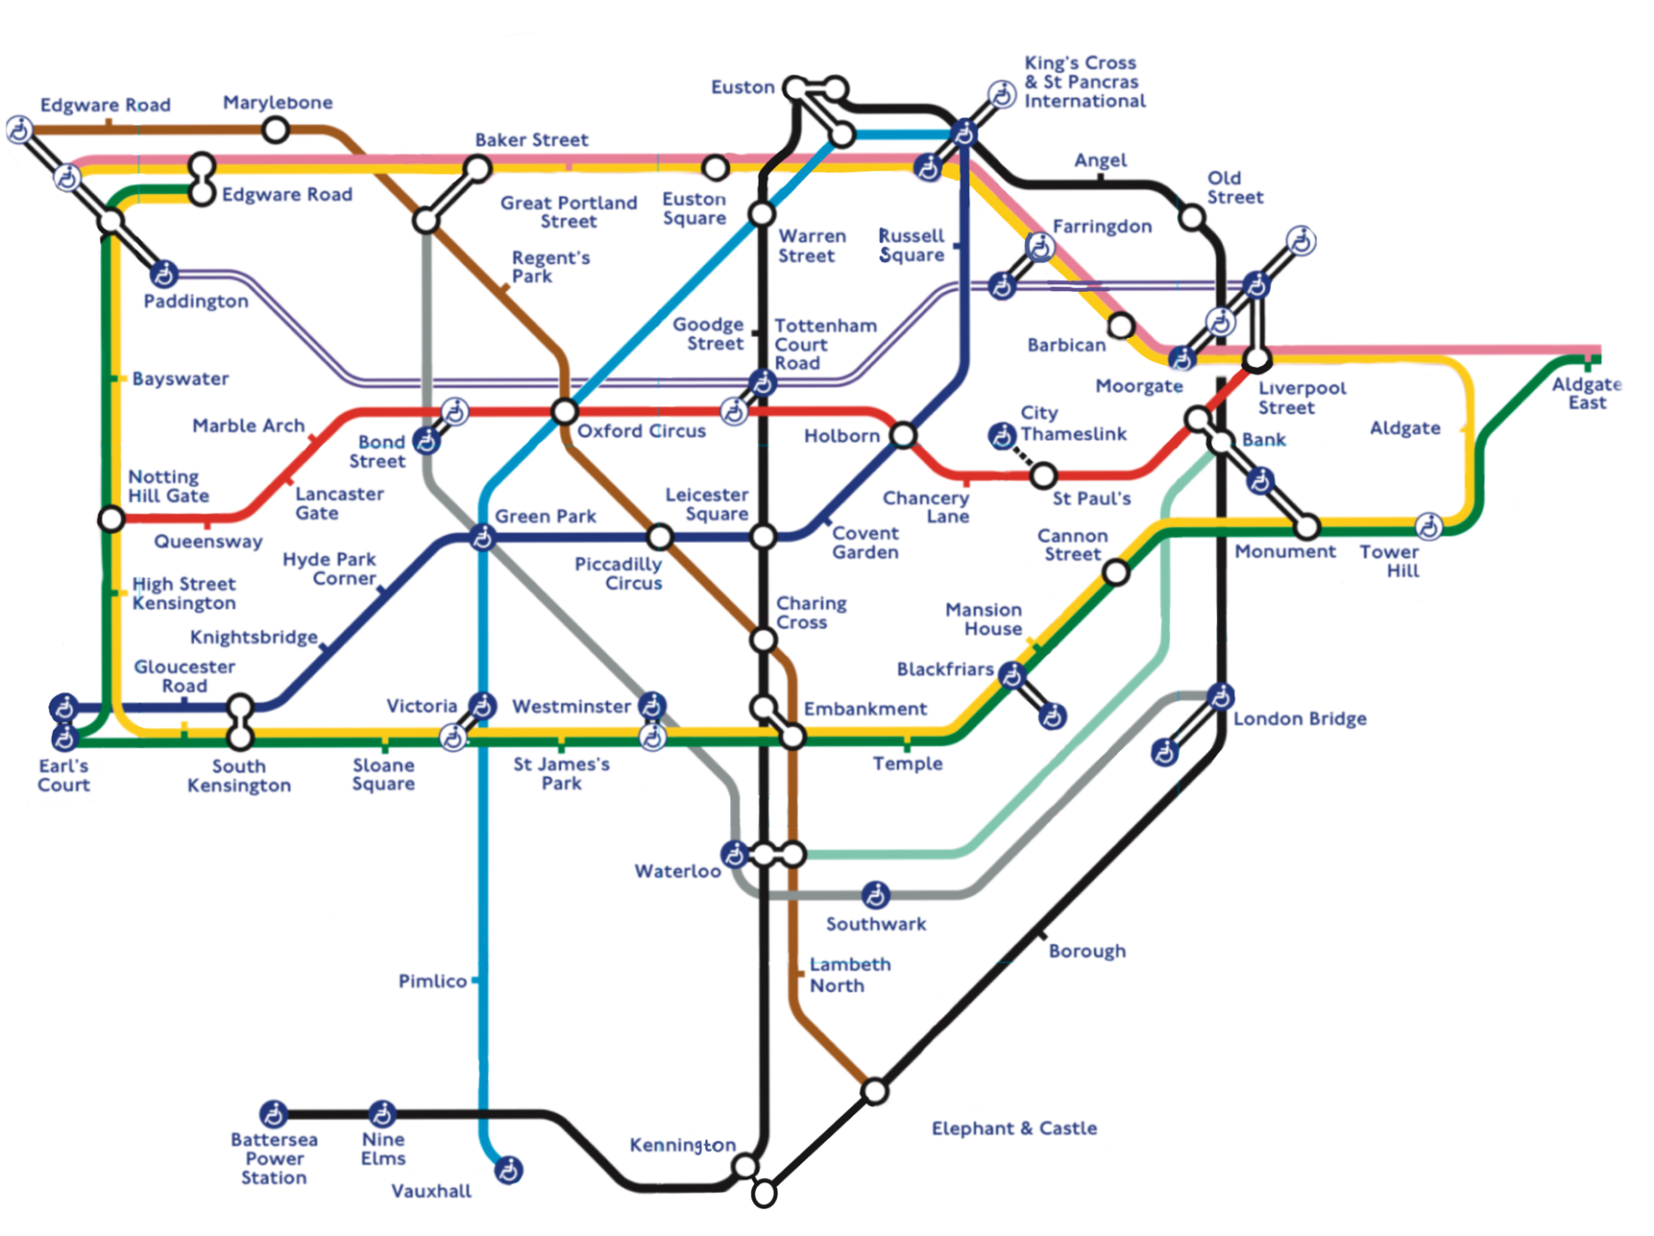As mentioned earlier in the background section, the project will involve the route with the least amount of time taken between two stations being calculated and outputted for the user. The line(s) used must also be outputted and the stations will only be in zone 1. The following section of the tube map will be used:

Therefore, the problem can be modelled using a graph: the nodes are the stations, and the arcs are the connections between the stations. This is shown below:

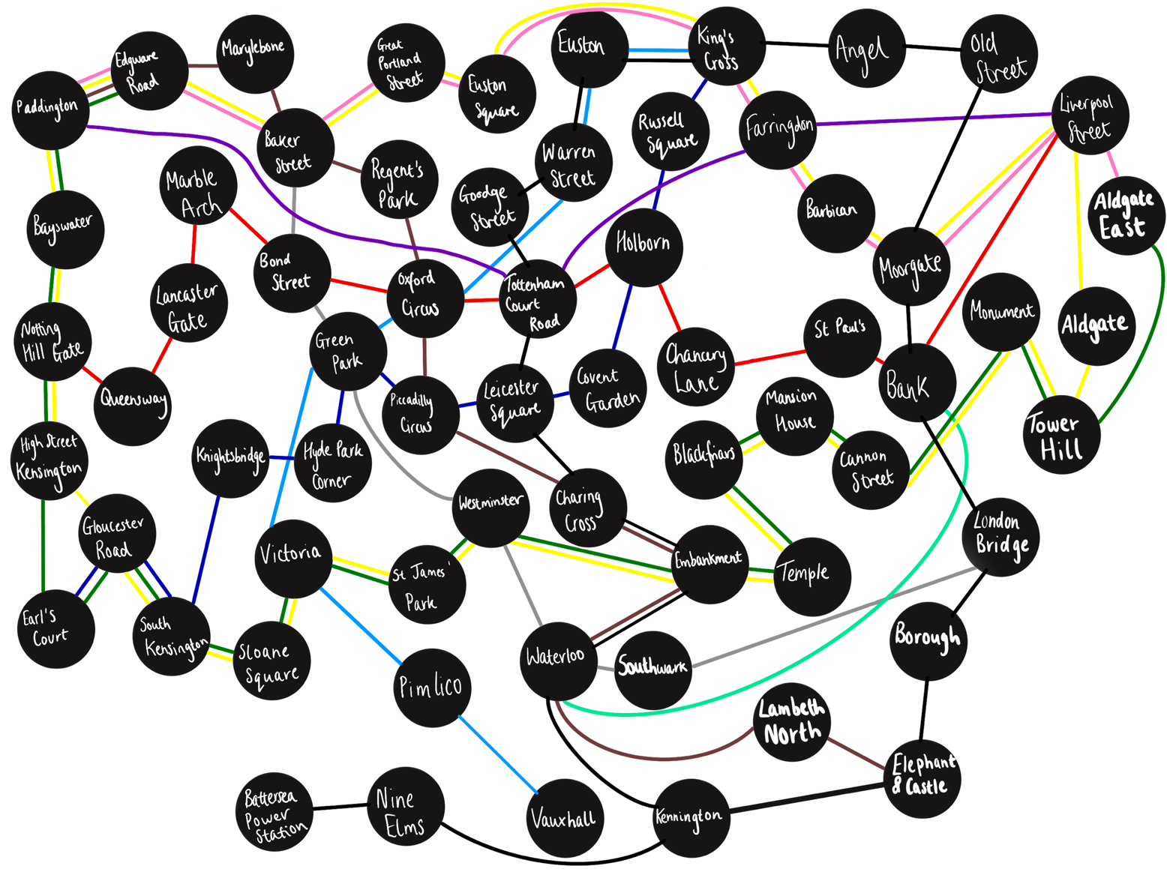This abstracted graph shows all of the zone 1 underground stations along with all possible connections between the stations and the lines used to travel from one another. It should be noted that, since the Metropolitan line has the same connections as the Circle line in zone 1, the Metropolitan line has been removed from the graph. Additionally, the Circle, District, and Hammersmith & City lines all use the same trains and platforms, so the timings for the Circle line will be used as the timings for the District line and the Hammersmith & City line where applicable.

Due to the fact that I can use a graph for this problem, I thought that the most suitable way to solve this problem would be by using Dijkstra’s shortest path algorithm. This algorithm has 4 steps:

1. Select the closest, unvisited node.
2. Calculate the distances to all other nodes (if you can, but if you cannot travel there then the distance is infinity).
3. Update the distances you already have if the new distance is smaller.
4. Mark that node as visited and repeat all steps until you have visited all nodes.

Since I am basing the shortest path on the amount of time taken between each station, the above steps can be changed slightly so that you calculate the times taken to get between the nodes instead of the distance between them.

At first, I created a Dijkstra’s algorithm function which involved using an adjacency list – which functioned more as an adjacency dictionary as it was easier to access items this way. I tried to check for a line change by searching for the two stations in a 2D array which contained lists of all of the routes (it contained lists of stations which came after one another in a line). By searching for the line being used and comparing it with the line that was previously used, I thought that the changeover time would be added, and the path would still be the shortest one. However, this produced some issues. If, for example, if you put in “Paddington” and “Marble Arch” as your start and end stations, it would produce a route. If you swapped the two stations so that “Marble Arch” is the start station and “Paddington” is the end station, it created a different route. Therefore, the algorithm was experiencing some problems due to the change of lines. If the algorithm was working correctly, then the same route would be outputted regardless of which order the stations were inputted in. Consequently, I decided to change my approach.

My new approach involved making each station on my graph have extra vertices depending on the lines that run there. For example, the Circle, District, Bakerloo, Hammersmith & City, and Elizabeth lines run at Paddington station. In my old approach, this would have been programmed like this in the adjacency list:



In my new approach, it is programmed like this:

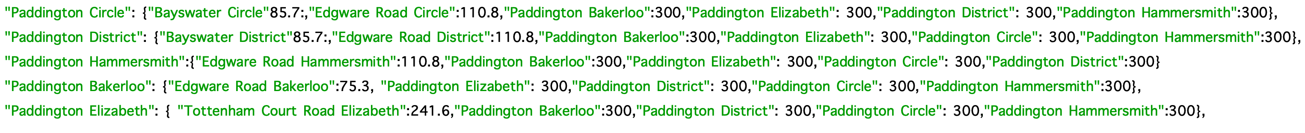

A different way of illustrating this change is as shown below:

Old approach:

New approach:

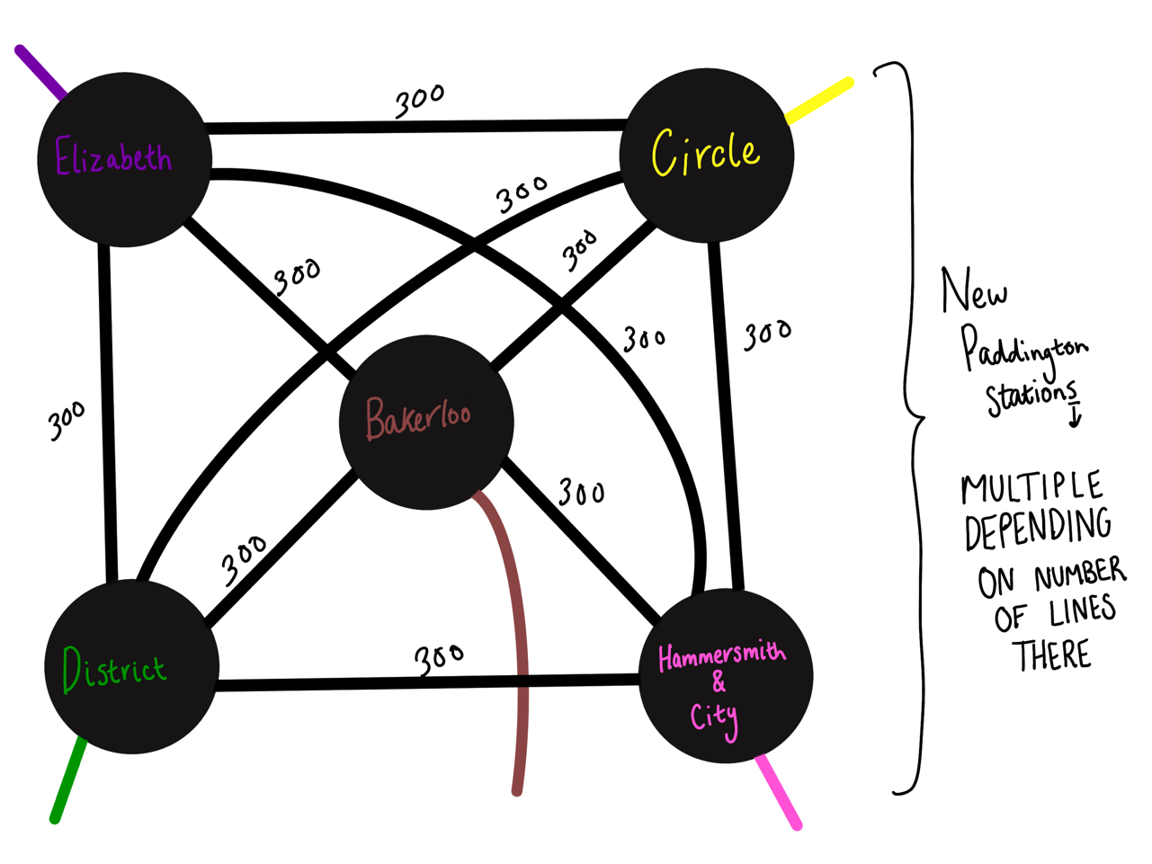

New Paddington **Stations**

Multiple substations depending on the number of lines at the station

Things to note about the new approach:

* Each station on the graph gets changed to a subgraph of Kn, a complete graph where n is the number of lines that can be used at the station.
* Every edge connecting the vertices of the same station gets a weighting of 300, which is the changeover time.

The first prototype did not work correctly, but after implementing the changes outlined above, the program worked correctly.

The First Prototype:

**import** cgi**,** cgitb**,** math

form **=** cgi**.**FieldStorage**()**

station1**=**form**.**getvalue**(**'station1'**)**

station2**=**form**.**getvalue**(**'station2'**)**

walking_speed**=**form**.**getvalue**(**'walking_speed'**)**

rush_hour**=**form**.**getvalue**(**'rush_hour'**)**

weekend**=**form**.**getvalue**(**'weekend'**)**

**print** **(**"Content-type:text/html\n\n"**)**

**print** **(**"<html>"**)**

**print** **(**"<head>"**)**

**print** **(**"<title>Tube Journey Planner</title>"**)**

**print** **(**"</head>"**)**

**print** **(**"<body>"**)**

**print** **(**"<h1>Route</h1>"**)**

routes **=** **[[**"Notting Hill Gate"**,** "Queensway"**,** "Lancaster Gate"**,** "Marble Arch"**,** "Bond Street"**,** "Oxford Circus"**,** "Tottenham Court Road"**,** "Holborn"**,** "Chancery Lane"**,**"St. Paul's"**,** "Bank"**,** "Liverpool Street"**],**

**[**"Elephant & Castle"**,** "Lambeth North"**,** "Waterloo"**,** "Embankment"**,** "Charing Cross"**,** "Piccadilly Circus"**,** "Oxford Circus"**,** "Regent's Park"**,** "Baker Street"**,** "Marylebone"**,** "Edgware Road"**,** "Paddington"**],**

**[**"Paddington"**,** "Bayswater"**,** "Notting Hill Gate"**,** "High Street Kensington"**,** "Gloucester Road"**,** "South Kensington"**,** "Sloane Square"**,** "Victoria"**,** "St. James's Park"**,** "Westminster" **,** "Embankment"**,** "Temple"**,** "Blackfriars"**,** "Mansion House"**,** "Cannon Street"**,** "Monument"**,** "Tower Hill"**,** "Aldgate"**,** "Liverpool Street"**,** "Moorgate"**,** "Barbican"**,** "Farringdon"**,** "King's Cross St. Pancras"**,**"Euston Square"**,** "Great Portland Street"**,** "Baker Street"**,** "Edgware Road"**,** "Paddington"**],**

**[**"Edgware Road"**,** "Paddington"**,** "Bayswater"**,** "Notting Hill Gate"**,** "High Street Kensington"**,** "Earl's Court"**,** "Gloucester Road"**,** "South Kensington"**,** "Sloane Square"**,** "Victoria"**,** "St. James's Park"**,** "Westminster" **,** "Embankment"**,** "Temple"**,** "Blackfriars"**,** "Mansion House"**,** "Cannon Street"**,** "Monument"**,** "Tower Hill"**,** "Aldgate East"**],**

**[**"Vauxhall"**,** "Pimlico"**,** "Victoria"**,** "Green Park"**,** "Oxford Circus"**,** "Warren Street"**,** "Euston"**,** "King's Cross St. Pancras"**],**

**[**"Earl's Court"**,** "Gloucester Road"**,** "South Kensington"**,** "Knightsbridge"**,** "Hyde Park Corner"**,** "Green Park"**,** "Piccadilly Circus"**,** "Leicester Square"**,** "Covent Garden"**,** "Holborn"**,** "Russell Square"**,** "King's Cross St. Pancras"**],**

**[**"Battersea Power Station"**,** "Nine Elms"**,** "Kennington"**,** "Waterloo"**,** "Embankment"**,** "Charing Cross"**,** "Leicester Square"**,** "Tottenham Court Road"**,** "Goodge Street"**,** "Warren Street"**,** "Euston"**,** "King's Cross St. Pancras"**,** "Angel"**,** "Old Street"**,** "Moorgate"**,** "Bank"**,** "London Bridge"**,** "Borough"**,** "Elephant & Castle"**,** "Kennington"**],**

**[**"London Bridge"**,** "Southwark"**,** "Waterloo"**,** "Westminster"**,** "Green Park"**,** "Bond Street"**,** "Baker Street"**],**

**[**"Paddington"**,** "Edgware Road"**,** " Baker Street"**,** "Great Portland Street"**,** "Euston Square"**,** "King's Cross St. Pancras"**,**" Farringdon"**,** "Barbican"**,** "Moorgate"**,** "Liverpool Street"**,** "Aldgate East"**],**

**[**"Waterloo"**,** "Bank"**],**

**[**"Paddington"**,** "Tottenham Court Road"**,** "Farringdon"**,** "Liverpool Street"**]]**

lines **=** **[**"Central"**,**"Bakerloo" **,**"Circle"**,**"District"**,**"Victoria"**,**"Piccadilly"**,**"Northern"**,**"Jubilee"**,**"Hammersmith & City"**,**"Waterloo & City"**,**"Elizabeth"**]**

#nearest .1second

#num_of_stations = 65

stations **=** **[**"Paddington"**,**"Bayswater"**,**"Notting Hill Gate"**,**"High Street Kensington"**,**"Earl's Court"**,**"Gloucester Road"**,**"South Kensington"**,**"Sloane Square"**,**"Victoria"**,**"St. James's Park"**,**"Westminster"**,**"Embankment"**,**"Temple"**,**"Blackfriars"**,**"Mansion House"**,**"Cannon Street"**,**"Monument"**,**"Tower Hill"**,**"Aldgate East"**,**"Aldgate"**,**"Liverpool Street"**,**"Moorgate"**,**"Barbican"**,**"Farringdon"**,**"King's Cross St. Pancras"**,**"Euston Square"**,**"Great Portland Street"**,**"Baker Street"**,**"Edgware Road"**,**"Marylebone"**,**"Angel"**,**"Old Street"**,**"Euston"**,**"Queensway"**,**"Lancaster Gate"**,**"Marble Arch"**,**"Bond Street"**,**"Green Park"**,**"Knightsbridge"**,**"Hyde Park Corner"**,**"Piccadilly Circus"**,**"Oxford Circus"**,**"Regent's Park"**,**"Tottenham Court Road"**,**"Goodge Street"**,**"Warren Street"**,**"Holborn"**,**"Russell Square"**,**"Leicester Square"**,**"Covent Garden"**,**"Chancery Lane"**,**"Charing Cross"**,**"Waterloo"**,**"Southwark"**,**"London Bridge"**,**"Borough"**,**"Lambeth North"**,**"Elephant & Castle"**,**"St. Paul's"**,**"Bank"**,**"Battersea Power Station"**,**"Nine Elms"**,**"Kennington"**,**"Pimlico"**,**"Vauxhall"**]**

stations_adjacency_dict**=** **{**

"Paddington"**:** **{**"Bayswater"**:**85.7**,**"Edgware Road"**:**93.1 **,** "Tottenham Court Road"**:**241.6**},**

"Bayswater"**:** **{**"Paddington"**:**85.7**,** "Notting Hill Gate"**:**86.1**},**

"Notting Hill Gate"**:** **{**"Bayswater"**:**86.1**,** "High Street Kensington"**:**87.3**,** "Queensway"**:**68.5**},**

"High Street Kensington"**:** **{**"Notting Hill Gate"**:**87.3**,** "Earl's Court"**:**132.9**,** "Gloucester Road"**:**150.1**},**

"Earl's Court"**:** **{**"High Street Kensington"**:**132.9**,**"Gloucester Road"**:**91.4**},**

"Gloucester Road"**:** **{**"Earl's Court"**:**91.4**,**"South Kensington"**:**77.4**,**"High street Kensington"**:**150.1**},**

"South Kensington"**:** **{**"Gloucester Road"**:**77.4**,**"Knightsbridge"**:**156.8**,**"Sloane Square"**:**110.4**},**

"Sloane Square"**:** **{**"South Kensington"**:**110.4**,**"Victoria"**:**88.7**},**

"Victoria"**:** **{**"Sloane Square"**:**88.7**,**"Pimlico"**:**82.3**,**"St. James's Park"**:**75.1**,**"Green Park"**:**78.4**},**

"St. James's Park"**:** **{**"Victoria"**:**75.1**,**"Westminster"**:**86.6**},**

"Westminster"**:** **{**"St. James's Park"**:**86.6**,**"Embankment"**:**81.6**,**"Waterloo"**:**78.1**,**"Green Park"**:**99.8**},**

"Embankment"**:** **{**"Westminster"**:**81.6**,**"Waterloo"**:**97.5**,**"Charing Cross"**:**50.4**,**"Temple"**:**66.4**},**

"Temple"**:** **{**"Embankment"**:**66.4**,**"Blackfriars"**:**86.6**},**

"Blackfriars"**:** **{**"Temple"**:**86.6**,**"Mansion House"**:**90.9**},**

"Mansion House"**:** **{**"Blackfriars"**:**90.9**,**"Cannon Street"**:**61.9**},**

"Cannon Street"**:** **{**"Mansion House"**:**61.9**,**"Monument"**:**66.3**},**

"Monument"**:** **{**"Cannon Street"**:**66.3**,**"Tower Hill"**:**92.5**},**

"Tower Hill"**:** **{**"Monument"**:**92.5**,**"Aldgate"**:**95.9**,**"Aldgate East"**:**132.9**},**

"Aldgate East"**:** **{**"Tower Hill"**:**132.9**,**"Liverpool Street"**:**128.4**},**

"Aldgate"**:** **{**"Tower Hill"**:**95.9**,**"Liverpool Street"**:**102.9**},**

"Liverpool Street"**:** **{**"Aldgate"**:**102.9**,**"Aldgate East"**:**128.4**,**"Farringdon"**:**96.0**,**"Moorgate"**:**70.6**,**"Bank"**:**97.5**},**

"Moorgate"**:** **{**"Liverpool Street"**:**70.6**,**"Bank"**:**88.5**,**"Barbican"**:**72.1**,**"Old Street"**:**99.5**},**

"Barbican"**:** **{**"Moorgate"**:**72.1**,**"Farringdon"**:**67.6**},**

"Farringdon"**:** **{**"Barbican"**:**67.6**,**"King's Cross St. Pancras"**:**164.0**,**"Liverpool Street"**:**96.0**,**"Tottenham Court Road"**:**138.8**},**

"King's Cross St. Pancras"**:** **{**"Farringdon"**:**164.0**,**"Euston Square"**:**83.2**,**"Euston"**:**91.6**,**"Angel"**:**119.7**,**"Russell Square"**:**89.2**},**

"Euston Square"**:** **{**"King's Cross St. Pancras"**:**83.2**,**"Great Portland Street"**:**65.9**},**

"Great Portland Street"**:** **{**"Euston Square"**:**65.9**,**"Baker Street"**:**88.4**},**

"Baker Street"**:** **{**"Great Portland Street"**:**88.4**,**"Edgware Road"**:**110.7**,**"Marylebone"**:**64.3**,**"Bond Street"**:**112.5**,**"Regent's Park"**:**98.9**},**

"Edgware Road"**:** **{**"Baker Street"**:**110.7**,**"Paddington"**:**93.1**,**"Marylebone"**:**69.1**},**

"Marylebone"**:** **{**"Edgware Road"**:**69.1**,**"Baker Street"**:**64.3**},**

"Angel"**:** **{**"King's Cross St. Pancras"**:**119.7**,**"Old Street"**:**122.4**},**

"Old Street"**:** **{**"Angel"**:**122.4**,**"Moorgate"**:**99.5**},**

"Euston"**:** **{**"King's Cross St. Pancras"**:**91.6**,**"Warren Street"**:**62.2**},**

"Queensway"**:** **{**"Notting Hill Gate"**:**68.5**,**"Lancaster Gate"**:**98.6**},**

"Lancaster Gate"**:** **{**"Queensway"**:**98.6**,**"Marble Arch"**:**101.2**},**

"Marble Arch"**:** **{**"Lancaster Gate"**:**101.2**,**"Bond Street"**:**105.5**},**

"Bond Street"**:** **{**"Marble Arch"**:**105.5**,**"Oxford Circus"**:**83.3**,**"Baker Street"**:**112.5**,**"Green Park"**:**94.3**},**

"Green Park"**:** **{**"Bond Street"**:**94.3**,**"Oxford Circus"**:**77.6**,**"Hyde Park Corner"**:**116.1**,**"Victoria"**:**78.4**,**"Piccadilly Circus"**:**67.0**,**"Westminster"**:**99.8**},**

"Knightsbridge"**:** **{**"South Kensington"**:**156.8**,**"Hyde Park Corner"**:**71.0**},**

"Hyde Park Corner"**:** **{**"Knightsbridge"**:**71.0**,**"Green Park"**:**116.1**},**

"Piccadilly Circus"**:** **{**"Green Park"**:**67.0**,**"Oxford Circus"**:**99.5**,**"Leicester Square"**:**68.9**,**"Charing Cross"**:**66.5**},**

"Oxford Circus"**:** **{**"Piccadilly Circus"**:**99.5**,**"Green Park"**:**77.6**,**"Bond Street"**:**83.3**,**"Regent's Park"**:**105.8**,**"Tottenham Court Road"**:**70.3**,**"Warren Street"**:**71.5**},**

"Regent's Park"**:** **{**"Baker Street"**:**98.9**,**"Oxford Circus"**:**105.8**},**

"Tottenham Court Road"**:** **{**"Oxford Circus"**:**70.3**,**"Holborn"**:**79.9**,**"Goodge Street"**:**63.2**,**"Leicester Square"**:**49.6**,**"Farringdon"**:**138.8**,**"Paddington"**:**241.6**},**

"Goodge Street"**:** **{**"Tottenham Court Road"**:**63.2**,**"Warren Street"**:**50.9**},**

"Warren Street"**:** **{**"Goodge Street"**:**50.9**,**"Euston"**:**62.2**,**"Oxford Circus"**:**71.5**},**

"Holborn"**:** **{**"Tottenham Court Road"**:**79.9**,**"Russell Square"**:**84.7**,**"Covent Garden"**:**86.7**,**"Chancery Lane"**:**48.5**},**

"Russell Square"**:** **{**"King's Cross St. Pancras"**:**89.2**,**"Holborn"**:**84.7**},**

"Leicester Square"**:** **{**"Tottenham Court Road"**:**49.6**,**"Piccadilly Circus"**:**68.9**,**"Charing Cross"**:**67.6**,**"Covent Garden"**:**44.9**},**

"Covent Garden"**:** **{**"Leicester Square"**:**44.9**,**"Holborn"**:**86.7**},**

"Chancery Lane"**:** **{**"Holborn"**:**48.5**,**"St. Paul's"**:**87.0**},**

"Charing Cross"**:** **{**"Embankment"**:**50.4**,**"Piccadilly Circus"**:**66.5**,**"Leicester Square"**:**67.6**},**

"Waterloo"**:** **{**"Kennington"**:**169.8**,**"Lambeth North"**:**87.8**,**"Westminster"**:**78.1**,**"Bank"**:**213.4**,**"Southwark"**:**49.5**,**"Embankment"**:**97.5**,**"Lambeth North"**:**87.8**},**

"Southwark"**:** **{**"Waterloo"**:**49.5**,**"London Bridge"**:**92.2**},**

"London Bridge"**:** **{**"Southwark"**:**92.2**,**"Bank"**:**79.8**,**"Borough"**:**79.0**},**

"Borough"**:** **{**"Elephant & Castle"**:**94.2**,**"London Bridge"**:**79.0**},**

"Lambeth North"**:** **{**"Waterloo"**:**87.8**,**"Elephant & Castle"**:**151.1**},**

"Elephant & Castle"**:** **{**"Lambeth North"**:**151.1**,**"Borough"**:**94.2**,**"Kennington"**:**100.7**},**

"St. Paul's"**:** **{**"Chancery Lane"**:**87.0**,**"Bank"**:**96.3**},**

"Bank"**:** **{**"London Bridge"**:**79.8**,**"St. Paul's"**:**96.3**,**"Moorgate"**:**88.5**,**"Liverpool Street"**:**97.5**,** "Waterloo"**:**213.4**},**

"Battersea Power Station"**:** **{**"Nine Elms"**:**98.8**},**

"Nine Elms"**:** **{**"Battersea Power Station"**:**98.8**,**"Kennington"**:**168.5**},**

"Kennington"**:** **{**"Nine Elms"**:**168.5**,**"Waterloo"**:**169.8**,**"Elephant & Castle"**:**100.7**},**

"Pimlico"**:** **{**"Vauxhall"**:**62.1**,**"Victoria"**:**82.3**},**

"Vauxhall"**:** **{**"Pimlico"**:**62.1**}**

**}**

**def** dijkstra**(**start_node**,**end_node**,** adj_list**,** nodes_list**,** rush_hour**,** weekend**,** walking_pace**,** routes**,** lines**):**

start_node_index **=** linear_search**(**start_node**,** nodes_list**)**

num_of_nodes **=** **len(**nodes_list**)**

num_of_lines **=** **len(**lines**)**

visited_nodes **=** **{**"Paddington"**:** **False,**

"Bayswater"**:** **False,**

"Notting Hill Gate"**:** **False,**

"High Street Kensington"**:** **False,**

"Earl's Court"**:** **False,**

"Gloucester Road"**:** **False,**

"South Kensington"**:** **False,**

"Sloane Square"**:** **False,**

"Victoria"**:** **False,**

"St. James's Park"**:** **False,**

"Westminster"**:** **False,**

"Embankment"**:** **False,**

"Temple"**:** **False,**

"Blackfriars"**:** **False,**

"Mansion House"**:** **False,**

"Cannon Street"**:** **False,**

"Monument"**:** **False,**

"Tower Hill"**:** **False,**

"Aldgate East"**:** **False,**

"Aldgate"**:** **False,**

"Liverpool Street"**:** **False,**

"Moorgate"**:** **False,**

"Barbican"**:** **False,**

"Farringdon"**:** **False,**

"King's Cross St. Pancras"**:** **False,**

"Euston Square"**:** **False,**

"Great Portland Street"**:** **False,**

"Baker Street"**:** **False,**

"Edgware Road"**:** **False,**

"Marylebone"**:** **False,**

"Angel"**:** **False,**

"Old Street"**:** **False,**

"Euston"**:** **False,**

"Queensway"**:** **False,**

"Lancaster Gate"**:** **False,**

"Marble Arch"**:** **False,**

"Bond Street"**:** **False,**

"Green Park"**:** **False,**

"Knightsbridge"**:** **False,**

"Hyde Park Corner"**:** **False,**

"Piccadilly Circus"**:** **False,**

"Oxford Circus"**:** **False,**

"Regent's Park"**:** **False,**

"Tottenham Court Road"**:** **False,**

"Goodge Street"**:** **False,**

"Warren Street"**:** **False,**

"Holborn"**:** **False,**

"Russell Square"**:** **False,**

"Leicester Square"**:** **False,**

"Covent Garden"**:** **False,**

"Chancery Lane"**:** **False,**

"Charing Cross"**:** **False,**

"Waterloo"**:** **False,**

"Southwark"**:** **False,**

"London Bridge"**:** **False,**

"Borough"**:** **False,**

"Lambeth North"**:** **False,**

"Elephant & Castle"**:** **False,**

"St. Paul's"**:** **False,**

"Bank"**:** **False,**

"Battersea Power Station"**:** **False,**

"Nine Elms"**:** **False,**

"Kennington"**:** **False,**

"Pimlico"**:** **False,**

"Vauxhall"**:** **False**

**}**

current_lines **=** lines_at_station**(**start_node**,**routes**,**lines**)**

lines_taken **=** **{}**

path_taken **=** **{}**

distances **=** **[**math**.**inf **for** i **in** **range** **(**num_of_nodes**)]**

distances**[**start_node_index**]** **=** 0

**if** walking_pace **==**"Slow"**:**

changeover_time **=** 420

**elif** walking_pace **==** "Fast"**:**

changeover_time **=** 180

**else:**

changeover_time **=** 300

**if** rush_hour **==** **True** **and** weekend **==** **True:**

multiplier **=** 2.5

**elif** rush_hour **==** **False** **and** weekend **==** **True:**

multiplier **=** 1.5

**elif** rush_hour **==** **True** **and** weekend **==** **False:**

multiplier **=** 2

**else:**

multiplier **=** 1

**for** i **in** **range(**num_of_nodes**):**

key **=** nodes_list**[**i**]**

**dict** **=** adj_list**[**key**]**

**for** j **in** **range(**num_of_nodes**):**

**try:**

node_key **=** nodes_list**[**j**]**

**dict[**node_key**]** **=** **dict[**node_key**]** **\*** multiplier

**except:**

exception **=** **True**

**for** i **in** **range** **(**num_of_nodes**):**

closest_node_index **=** **None**

#SELECT CLOSEST UNVISITED NODE:

**for** j **in** **range(**num_of_nodes**):**

**if** i **==** 0**:**

closest_node_index **=** start_node_index

**elif** closest_node_index **==** **None:**

**for** k **in** **range(**num_of_nodes**):**

key **=** nodes_list**[**k**]**

**if** visited_nodes**[**key**]** **==** **False** **and** distances**[**k**]** **!=** math**.**inf **and** distances**[**k**]** **!=** 0**:**

closest_node_index **=** k

**elif** distances**[**j**]** **<** distances**[**closest_node_index**]** **and** visited_nodes**[**nodes_list**[**j**]]** **==** **False:**

closest_node_index **=** j

current_node_index **=** closest_node_index

current_node **=** nodes_list**[**current_node_index**]**

visited_nodes**[**current_node**]** **=** **True**

direct_nodes_list **=** adj_list**[**current_node**]**

start_add_on **=** distances**[**current_node_index**]**

**if** i **==** 0**:**

lines_taken**[**start_node**]** **=** lines

**else:**

through_node **=** path_taken**[**current_node**]**

current_lines **=** lines_taken**[**through_node**]**

**for** j **in** **range(**num_of_nodes**):**

new_distance **=** 0

**try:**

key **=** nodes_list**[**j**]**

new_distance **=** direct_nodes_list**[**key**]** **+** start_add_on

#CHECK IF ON THE SAME LINE AND THEN UPDATE DISTANCE IF IT IS LESS THAN DISTANCE ALREADY RECORDED

new_line**,** possible_lines **=** check_line**(**current_node**,**key**,**routes**,**lines**,**current_lines**)**

**if** new_line **==** **True:**

new_distance **+=** changeover_time

**if** new_distance **<** distances**[**j**]** **and** visited_nodes**[**key**]** **==** **False:**

distances**[**j**]** **=** new_distance

path_taken**[**key**]** **=** current_node

lines_taken**[**key**]** **=** possible_lines

**except:**

exception **=** **True**

path_list **=** **[**end_node**]**

path_list **=** recursive_find_path**(**start_node**,**end_node**,**path_taken**,**path_list**)**

path_list**.**reverse**()**

lines_list_final **=** final_lines**(**lines_taken**,** start_node**,** end_node**,** path_list**)**

text1**,**text2**,**text3**,**text4 **=** display_all**(**path_list**,**distances**,**lines_list_final**,**end_node**,**nodes_list**)**

**return** text1**,**text2**,**text3**,**text4

**def** lines_at_station**(**start_node**,**routes**,**lines**):**

empty **=** **[]**

**for** i **in** **range** **(len(**lines**)):**

line **=** routes**[**i**]**

**if** start_node **in** line**:**

empty**.**append**(**lines**[**i**])**

**return** empty

**def** linear_search**(**target**,**items**):**

length_of_list **=** **len(**items**)**

**for** i **in** **range(**length_of_list**):**

**if** items**[**i**]** **==** target**:**

**return** i

**return** **-**1

**def** check_line**(**current_node**,**travelling_node**,**routes**,**lines**,**current_lines**):**

possible_lines **=** **[]**

changed_line **=** **False**

**for** i **in** **range(len(**lines**)):**

line_route **=** routes**[**i**]**

**for** j **in** **range(len(**line_route**)):**

**try:**

**if** **((**line_route**[**j**]** **==** current_node **and** line_route**[**j **+** 1**]** **==** travelling_node**)** **or** **(**line_route**[**j**]** **==** travelling_node **and** line_route**[**j**+**1**]** **==** current_node**)):**

new_line **=** lines**[**i**]**

possible_lines**.**append**(**new_line**)**

**except:**

exception **=** **True**

**for** line **in** possible_lines**:**

**if** line **not** **in** current_lines**:**

changed_line **=** **True**

**return** changed_line**,** possible_lines

**def** recursive_find_path**(**start_node**,**end_node**,**path_dict**,**path_list**):**

**try:**

**if** path_dict**[**end_node**]** **==** start_node**:**

path_list**.**append**(**path_dict**[**end_node**])**

**return** path_list

**else:**

next_node **=** path_dict**[**end_node**]**

path_list**.**append**(**next_node**)**

recursive_find_path**(**start_node**,**next_node**,**path_dict**,**path_list**)**

**return** path_list

**except:**

exception **=** **True**

**def** final_lines**(**lines_dict**,** start_node**,** end_node**,** path_list**):**

new_lines_list **=** **[]**

**for** i **in** **range(len(**path_list**)** **-**1**):**

new_lines_list**.**append**(**lines_dict**[**path_list**[**i**+**1**]])**

ready **=** **False**

**while** ready **==** **False:**

ready **=** **True**

**for** i **in** **range(len(**new_lines_list**)):**

segment **=** new_lines_list**[**i**]**

**if** **len(**segment**)** **>** 1**:**

ready **=** **False**

**for** i **in** **range(len(**new_lines_list**)):**

segment1 **=** new_lines_list**[**i**]**

**if** **len(**segment1**)** **==** 1**:**

**try:**

segment2 **=** new_lines_list**[**i**+**1**]**

**if** **len(**segment2**)** **>**1**:**

**if** segment1**[**0**]** **in** segment2**:**

new_lines_list**[**i**+**1**]** **=** segment1**[**0**]**

**except:**

exception **=** **True**

**try:**

segment2 **=** new_lines_list**[**i**-**1**]**

**if** **len(**segment2**)** **>** 1**:**

**if** segment1**[**0**]** **in** segment2**:**

new_lines_list**[**i**-**1**]** **=** segment1

**except:**

exception **=** **True**

**return** new_lines_list

**def** display_all**(**path_list**,**distances**,**lines_list**,**end_node**,**nodes_list**):**

text1 **=** ""

text2 **=** ""

**for** i **in** **range** **(len(**path_list**)):**

**if** i **<** **len(**lines_list**):**

text2 **+=** **str(**lines_list**[**i**])** **+** " , "

text2 **=** text2**.**replace**(**"['"**,**""**)**

text2 **=** text2**.**replace**(**"']"**,**""**)**

text1 **+=** path_list**[**i**]** **+** " , "

end_node_index **=** linear_search**(**end_node**,**nodes_list**)**

text3 **=** **str(**distances**[**end_node_index**])** **+** " seconds"

text4 **=** **str(**distances**[**end_node_index**]** **/** 60**)** **+** " minutes"

**return** text1**,**text2**,** text3**,** text4

text1**,**text2**,**text3**,**text4 **=** dijkstra**(**station1**,** station2**,** stations_adjacency_dict**,** stations**,** rush_hour**,** weekend**,** walking_speed**,** routes**,** lines**)**

**print(**"<h2> Route: %s</h2>" **%** text1**)**

**print(**"<h2> Lines: %s</h2>" **%** text2**)**

**print(**"<h2> Approximated Time: %s</h2>" **%** text3**)**

**print(**"<h2> Approximated Time: %s</h2>" **%** text4**)**

**print** **(**"<a href='../journeyplanner.html'>Journey Planner<a>"**)**

**print** **(**"</body>"**)**

**print** **(**"</html>"**)**

Questionnaire for Prospective End-Users – Section 5:

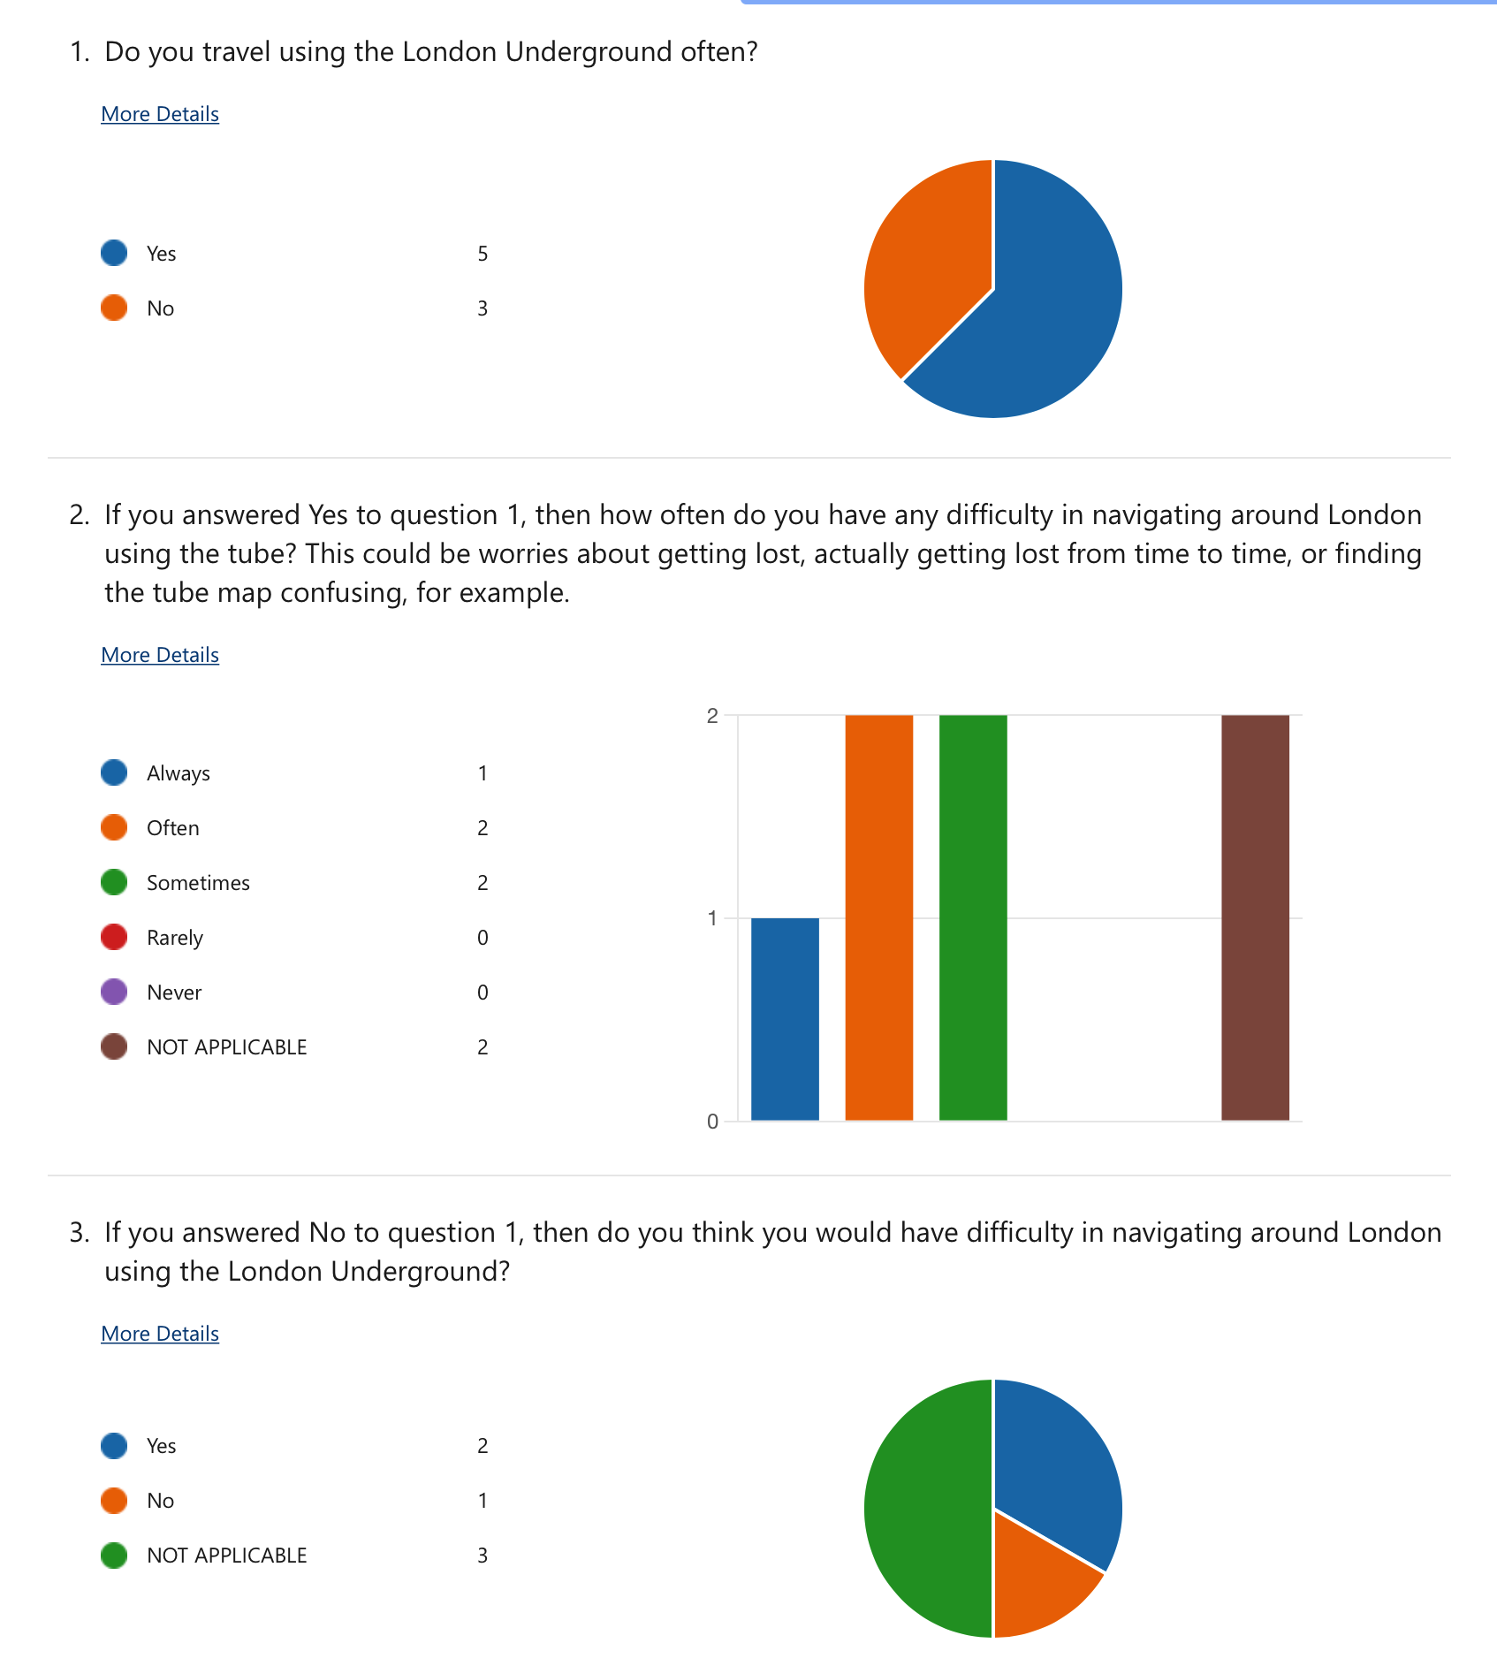I created a questionnaire on people’s attitudes towards the tube, specifically navigating using it and their worries/concerns about getting lost etc. The people who completed the questionnaire are between 17 and 55. The questions and results are listed below:

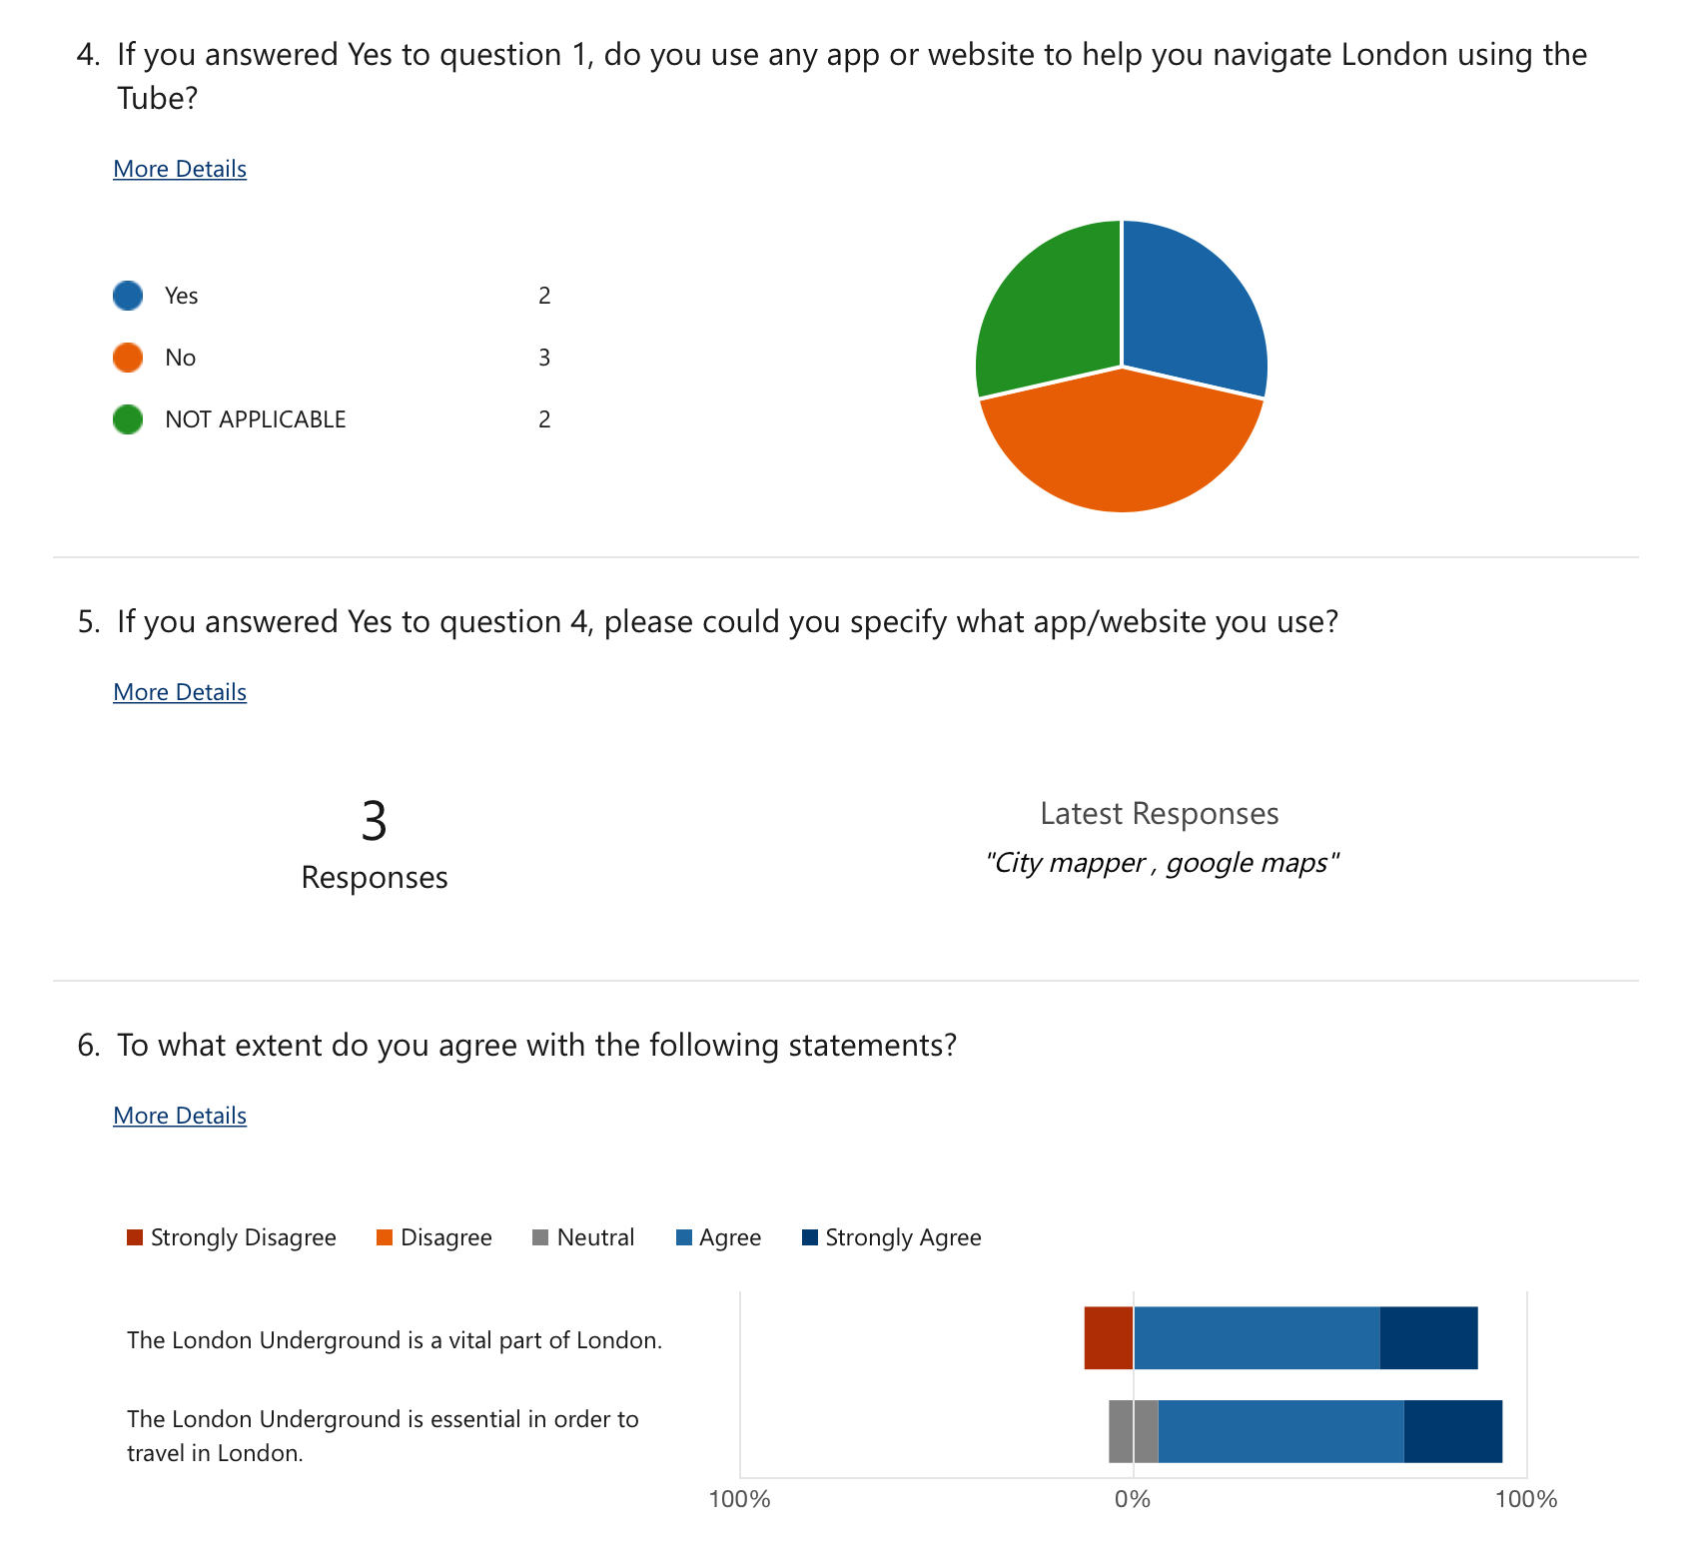

Question: Do you think that the tube map and navigating via the tube is difficult or overwhelming?

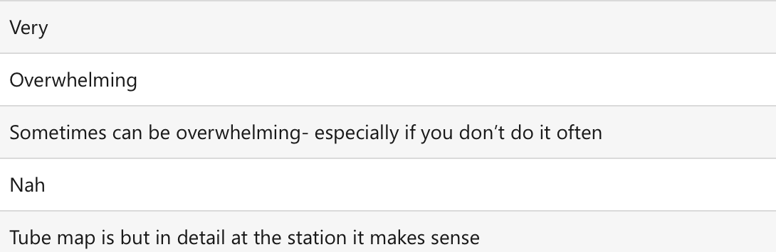Answers:

Question: If you could, what would you put in a website that helps people navigate via the Tube? For example, a journey planner, or status updates etc.

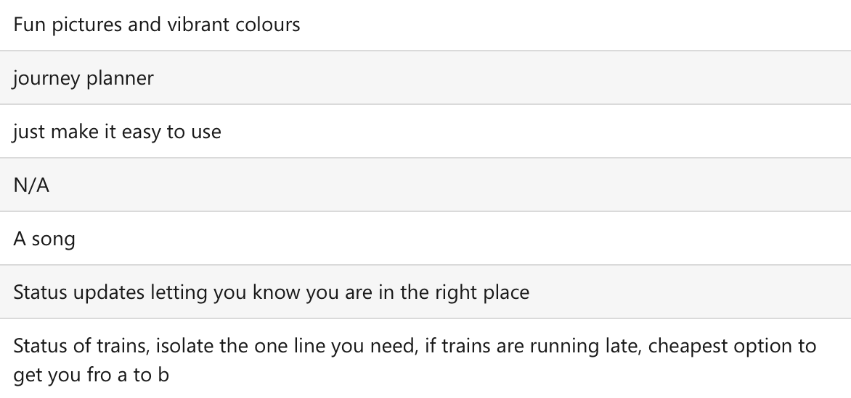Answers:

Conclusions:

* People think that the tube map is overwhelming and navigating via the Tube is difficult.
* People want status updates and a simple user interface for a program which helps them navigate London via the Tube.
* People want to use a program which has a simple user interface, so that it is not difficult to use.

Interview with Prospective End-User – Section 6:

The interview was conducted with an individual who travels using the London Underground often but does not live in London. It was a semi-structured interview, so some questions were already prepared but more questions were also asked if necessary.

1. **Do you travel in London often?**

End-User: “Sometimes. I am going to go to London in the next month.”

Interviewer: “Are you planning on using the London Underground when you go?”

End-User: “Yes, I always use the London Underground when I am in London. I am going to use the Tube in zones 1 and 2.”

1. **How often do you use the London Underground when you go to London?**

End-User: “Every time I go to London, I use the London Underground. I don’t use buses or any other modes of transport since it is more expensive and slower than the Tube.”

1. **Do you ever have difficulty navigating around London via the Tube?**

End-User: “Not anymore, but when I was new to London and I was using the tube for the first time, then yes it was overwhelming. It definitely took a while to get used to the whole system.”

1. **Have you ever felt nervous/confused when using the Tube?**

End-User: “Yeah, when I first moved to Cambridge from Scotland, I went to London frequently and it was confusing.”

Interviewer: “Do you have any specific bad experiences on the Tube?”

End-User: “Yeah, me and my sister were in London and I accidentally read one of the stations wrong. So, we ended up at the wrong stop, but we realised this and made our way back to the station we needed to get off at.”

Interviewer: “Was this experience scary or inconvenient in any way?”

End-User: “No it wasn’t scary, but it was inconvenient as we had to go back to where we came from. It also took us more time which was quite annoying.”

1. **Do you agree that the London Underground is a vital part of London and is essential in order to travel in London?**

End-User: “Yes absolutely – many people rely on it and the recent strikes have caused lots of disruption since capacity on buses is very limited.”

1. **Do you think that this app’s user interface is overwhelming or hard to use? Any other opinions on them?** (Involved showing screenshots of the app – shown in section 2).
2. Apple Maps:

End-User: “It’s a good user interface for the start page, but it is hard to find a direct route. I have used this app before and there is a long process when searching for the stations. If you are not already at the station you want to see the route for, then you have to manually change the start location. So, it is time consuming but people using the app may be in a rush. It doesn’t show much information. It only shows the same amount of information as the tube map, which is not very useful. It’s also a bit more confusing compared to the tube map since it is geographically accurate. If I’m getting the Tube, I only want to see relevant information so I wouldn’t bother using this app.”

1. TfL Go:

End-User: “It’s okay but it could be made easier. I like that it can show you the fastest option, and different routes you can take like Tube, bus, cycle etc.

Interviewer: “You said it can be made easier – what do you mean by that specifically?”

End-User: “It could be made easier to use for someone in a rush because it has a lot of steps you have to go through in order to get to your route, and everyone in London is in a rush.”

1. CityMapper:

End-User: “I don’t like the colours. It’s too colourful and there is too much going on. I think the background should be white and not blue. I like that there are more options for your route like you can go by bus, Tube step-free, scooter, cycle etc. There’s also a save CO2 option which is cool. I don’t like the advertisements in the way of everything – I only want to see the route. I like that there are prices written on there, but the icons are too small. I think it should be more focussed on the Tube and the icon should be bigger because it is the most important mode of transport in London.

1. **What features would you like on a website which can plan your journey between two Tube stations?**

End-User: “I would like updates of any disruptions of trains. I would also want a picture of the map just to confirm my route. I would like to see the estimated time taken to get to the station I want to go to. I would only want the simple information that I need and without too many colours. It would be cool if it could show you how busy the tube is at that time.

Set Of Objectives – Section 7:

Based on the research collected from the prospective end-user, the objectives are as follows:

1. The program will be a website which will find the optimal route from one tube station to another.

1.1. The website should allow you to input your start location and end location with a dropdown menu.

1.2. The website should find the optimal route based on the time taken to get between each station.

1.3. The website should allow for a 5-minute change over to another line and the times between each station will be measured at an off-peak time, recorded, and inputted in the program.

1.4. The website should only focus on zone 1 of the London Underground, as stations outside of zone 1 have less routes that can be taken and, therefore, an optimal route may be the only route.

1.5. The website should display which lines you need to use in order to travel to your destination.

2. The program should use Dijkstra’s algorithm in order to find the shortest path between two tube stations.

2.1. The program should use a graph which is abstracted (only has the necessary information, such as station name, connections between stations, and times taken between each station) in order to represent the problem.

2.2. The program should represent the graph using an adjacency list (of some sort) in order for the problem to be solved.

3. The website should have multiple webpages which can be navigated by the user.

3.1. These webpages will be accessible from the navbar.

3.2. The webpages will include a homepage (a page with information on the website’s functionality and background), a map webpage (page where you can view the tube map), a journey planner webpage (a page where you input your tube stations and the program gives you the optimal route), a status updates webpage (a page where you can view status updates of each line), an arrival times webpage (a page where you can view the arrival times at a specified station), and a lift updates webpage (a page where you can see if there are any lifts which are not working at a specified station).

3.3. The status updates, arrival times, and lift updates webpages will use the TfL API in order to inform the user of the information they have requested.

4. The website should have a user interface which is easy to navigate.

4.1. The website should have a navbar, a header, and a footer.

4.2. The website should use CSS for styling each section.

4.3. The website should have a drop-down menu to show each station when inputting the start and end locations in the journey planner to ensure that the user input is valid.

5. The program should have an option to adjust journey times based on what time of day the user is using it. Then, the program should output the estimated time taken to get to their desired destination from their start location.

5.1. If it is a rush hour, then all of the times should be multiplied by 2.

5.2. If it is a weekend, then all of the times should be multiplied by 1.5.

5.3. If it is rush hour on a weekend, then all of the times should be multiplied by 2.5.

6. The program should explain how the website can be used and what it can be used for.

6.1. In the current systems, the journey planners are quite complex and may be hard to understand for some users. Therefore, my program should have a clear description for how the program can be used and should not have any unnecessary or complex details such as text in the way of anything.

6.2. The user interface should not be too confusing or overwhelming: it should be based on simplicity so that many different users are able to use it with ease.

7. The program should have a normal journey planner (including all stations in zone 1), and a step-free journey planner (with only step free stations in zone 1).

7.1 The journey planner should have an option on the form which asks if they would like to use the step-free journey planner or not.

7.2 The step-free journey planner should allow for additional time while getting from the street to the platform and the platform to the street.

8. The program should output the route for the user in a way which is easy to understand.

8.1. The outputs should include the station name and the line used. The line used must be included because otherwise, the user will be left to figure out the line they need by themselves which does not fulfil the needs of the project, as people using the tube are usually in a hurry and don’t have time to check the map.

8.2. The outputs should be formatted as below:

*Station name (line used) ->*

*Next station (line used) -> etc.*

9. The program should effectively output the TfL API data so that it is easy for the user to understand.

9.1. The arrivals webpage should display each arrival in the order in which it is received, and it should display the line which is used, which direction the train will be going, and the time at which it will arrive.

9.2. The status updates webpage should display an image of the stations on the line, along with the information received from the TfL API in the correct order it was received.

10. The program should use CGI in order for the client to communicate with the server and access the required content.

10.1. The program should have a python web server file which is used to access the service.

Acceptable Limitations – Section 9:

The main limitations I encountered were data collection limitations. Since I was collecting the data myself, it was not possible to collect data on all of the zones. Therefore, I decided to only use zone 1. This is an acceptable limitation because, as you get further away from zone 1, there are less routes you can take and less lines you can take to get between stations. This means that it is much easier to plan your route as it may be the only route you can take. Additionally, it would be less stressful, as the stations are less busy, and the maps are easier to understand as the stations are not as close together as they are in zone 1.

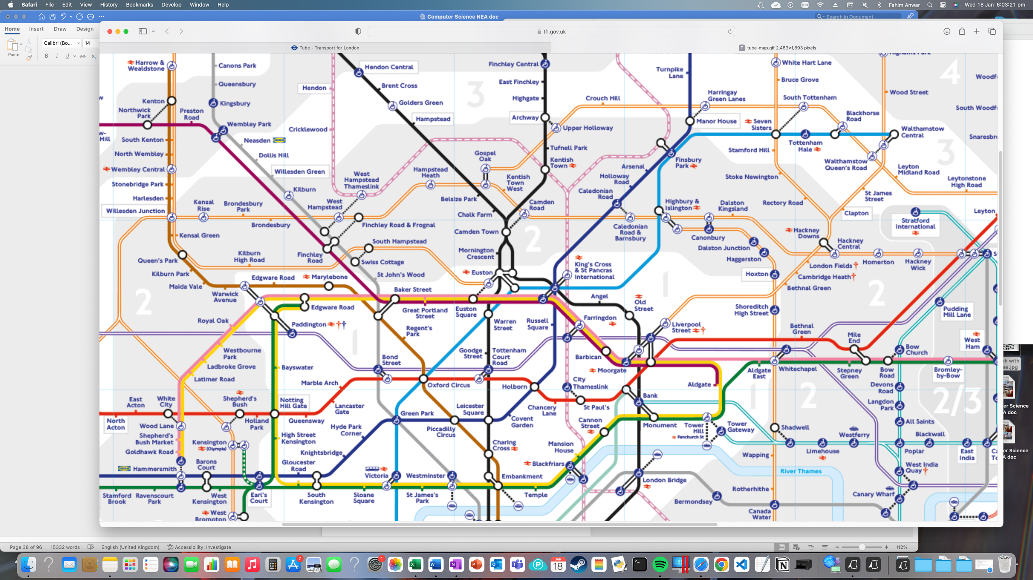Additionally, when collecting my data in one 1, I saw that there are many lines which can take you between the same two stations, for example, the metropolitan line and circle line have the same routes in zone 1 for some stations (maroon and yellow lines):

I decided to leave out the metropolitan line while collecting data, and instead use the same timings from the circle line. This is an acceptable limitation, as it would have taken significantly longer if I had done the metropolitan line data collection as well. Additionally, since the metropolitan line in zone 1 is part of the circle line, it makes sense to use the circle line timings and omit the metropolitan line from the data collection stage.